Lab No: 01

1. Create a DB named “BUBT_DB1”.

Query:

[create](http://localhost/phpmyadmin/url.php?url=https://dev.mysql.com/doc/refman/8.0/en/create-database.html) [database](http://localhost/phpmyadmin/url.php?url=https://dev.mysql.com/doc/refman/8.0/en/create-database.html) BUBT_DB1;

2. Create three tables in this DB named “Student”, “Faculty”, “Course”.

Query:

CREATE table student(Name varchar(30),ST_ID int(2),NID int(3),Intake int(2),Section int(2),CGPA float(3.2));

INSERT INTO student VALUES('Ashraful','1','102','44','1','3.30');

INSERT INTO student VALUES('Tonny', '2', '101', '44', '1', '3.50');

INSERT INTO student VALUES('Zakir', '33', '103', '35', '2', '3.98');

INSERT INTO student VALUES('Urmi', '6', '104', '35', '1', '3.96');

INSERT INTO student VALUES('Tonny', '23', '105', '44', '1', '3.50');

Output:

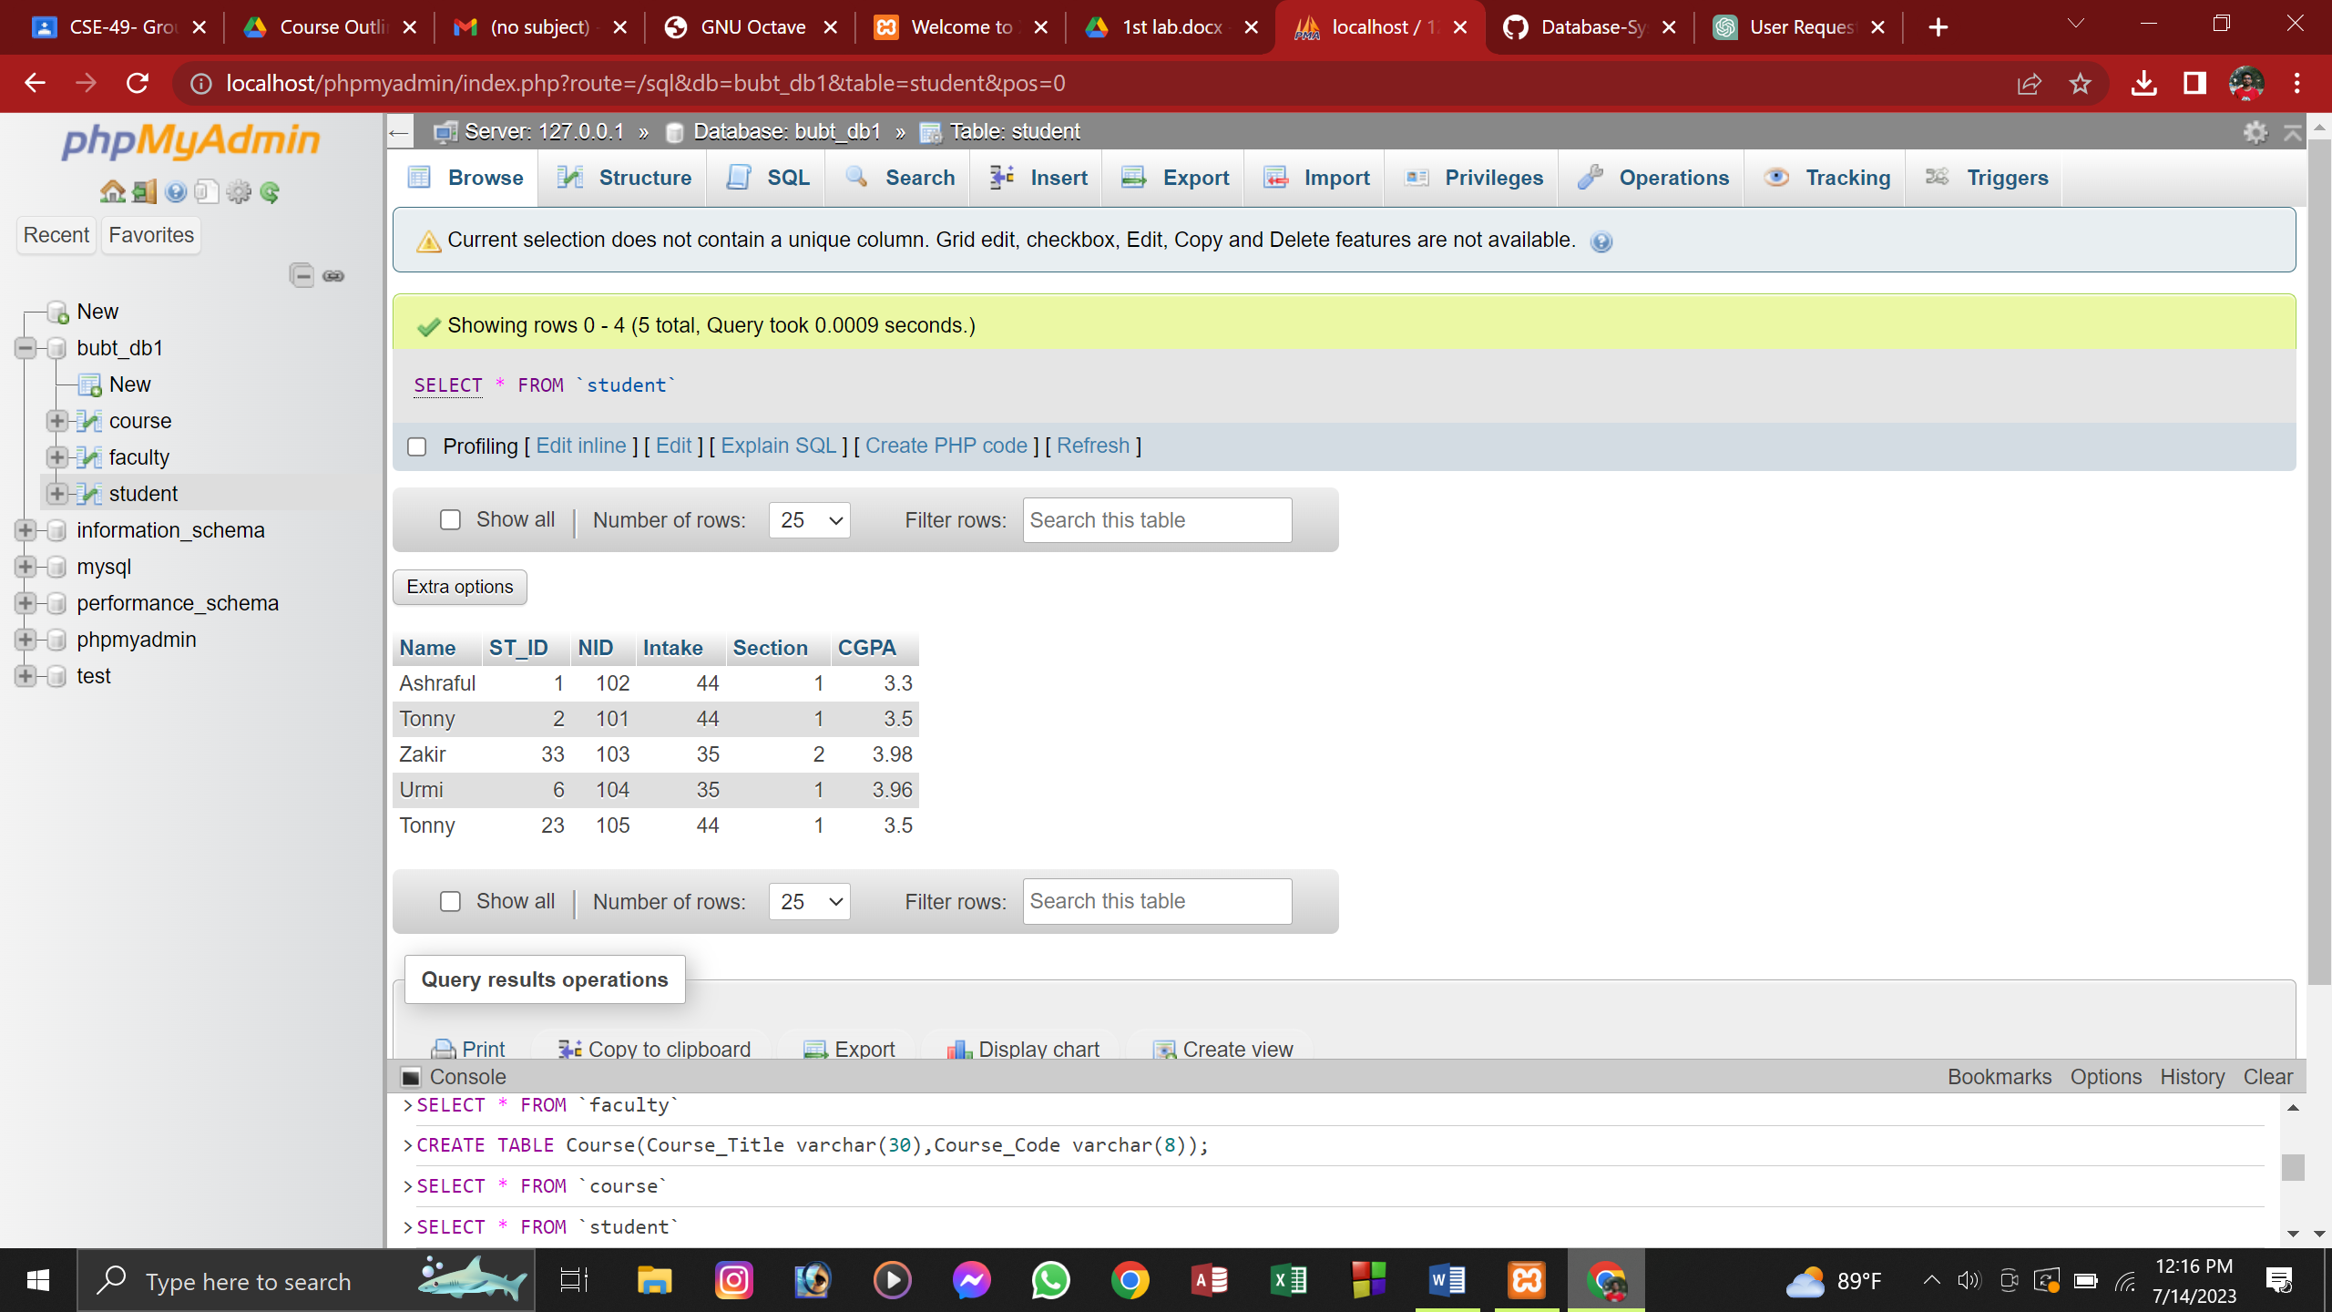

CREATE TABLE Faculty(Name varchar(30),Short_Code varchar(7),Course_Code varchar(8),Conduct_Semester varchar(15));

INSERT INTO faculty VALUES('Farha Akhter Munmun','FAM','CSE 319','Summer 2019');

INSERT INTO faculty VALUES('Sweety Lima', 'SWL', 'CSE 209', 'Fall 2019-20');

INSERT INTO faculty VALUES('Shumi Khatun', 'SKN', 'NULL', 'Summer 2019');

INSERT INTO faculty VALUES('Nadia Afrin Ritu','NULL', 'CSE 351', 'NULL');

Output:

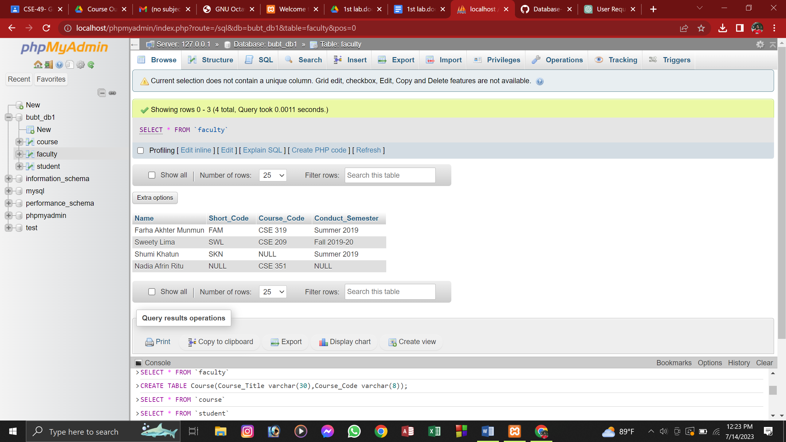

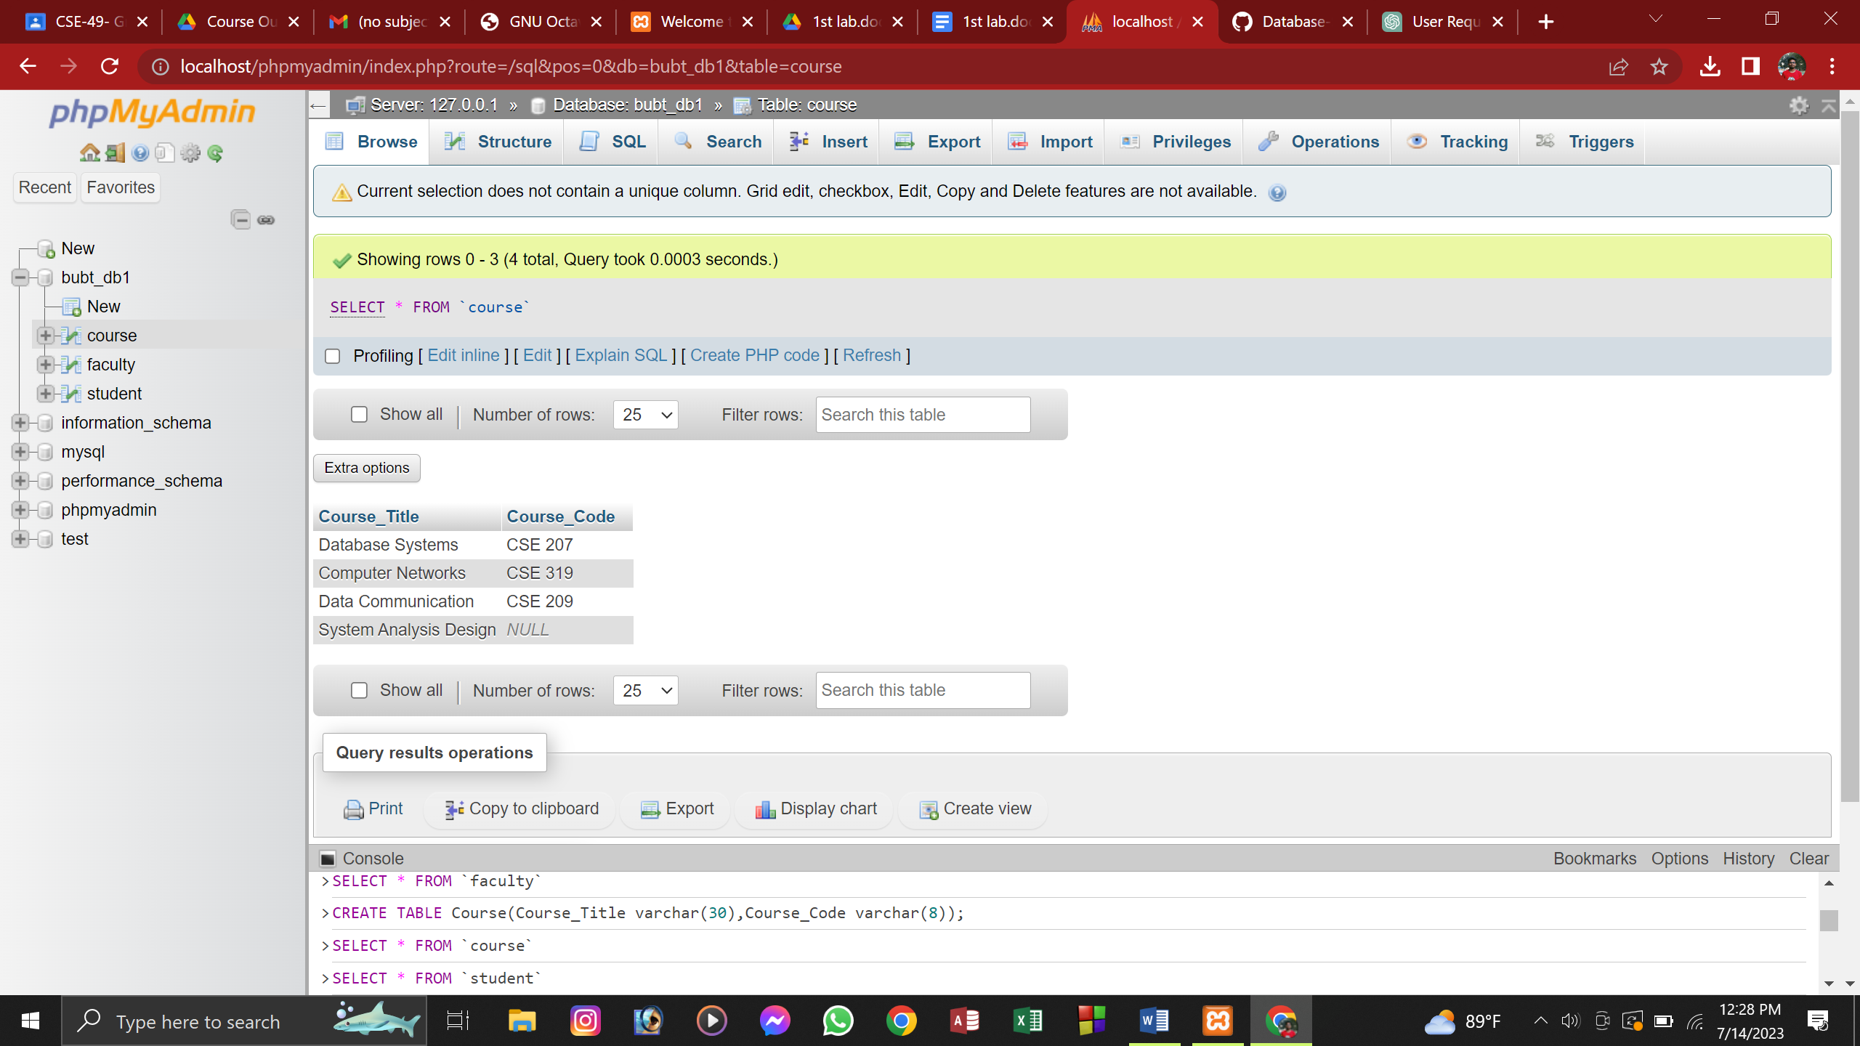

CREATE TABLE Course(Course_Title varchar(30),Course_Code varchar(8));

INSERT INTO course VALUES ('Database Systems', 'CSE 207');

INSERT INTO course VALUES('Computer Networks', 'CSE 319');

INSERT INTO course VALUES('Data Communication', 'CSE 209');

INSERT INTO course VALUES('System Analysis Design', NULL);

3.

a) Update the short code whose short code is NULL.

Query:

UPDATE faculty SET Short_Code='NAR' WHERE Name='Nadia Afrin Ritu';

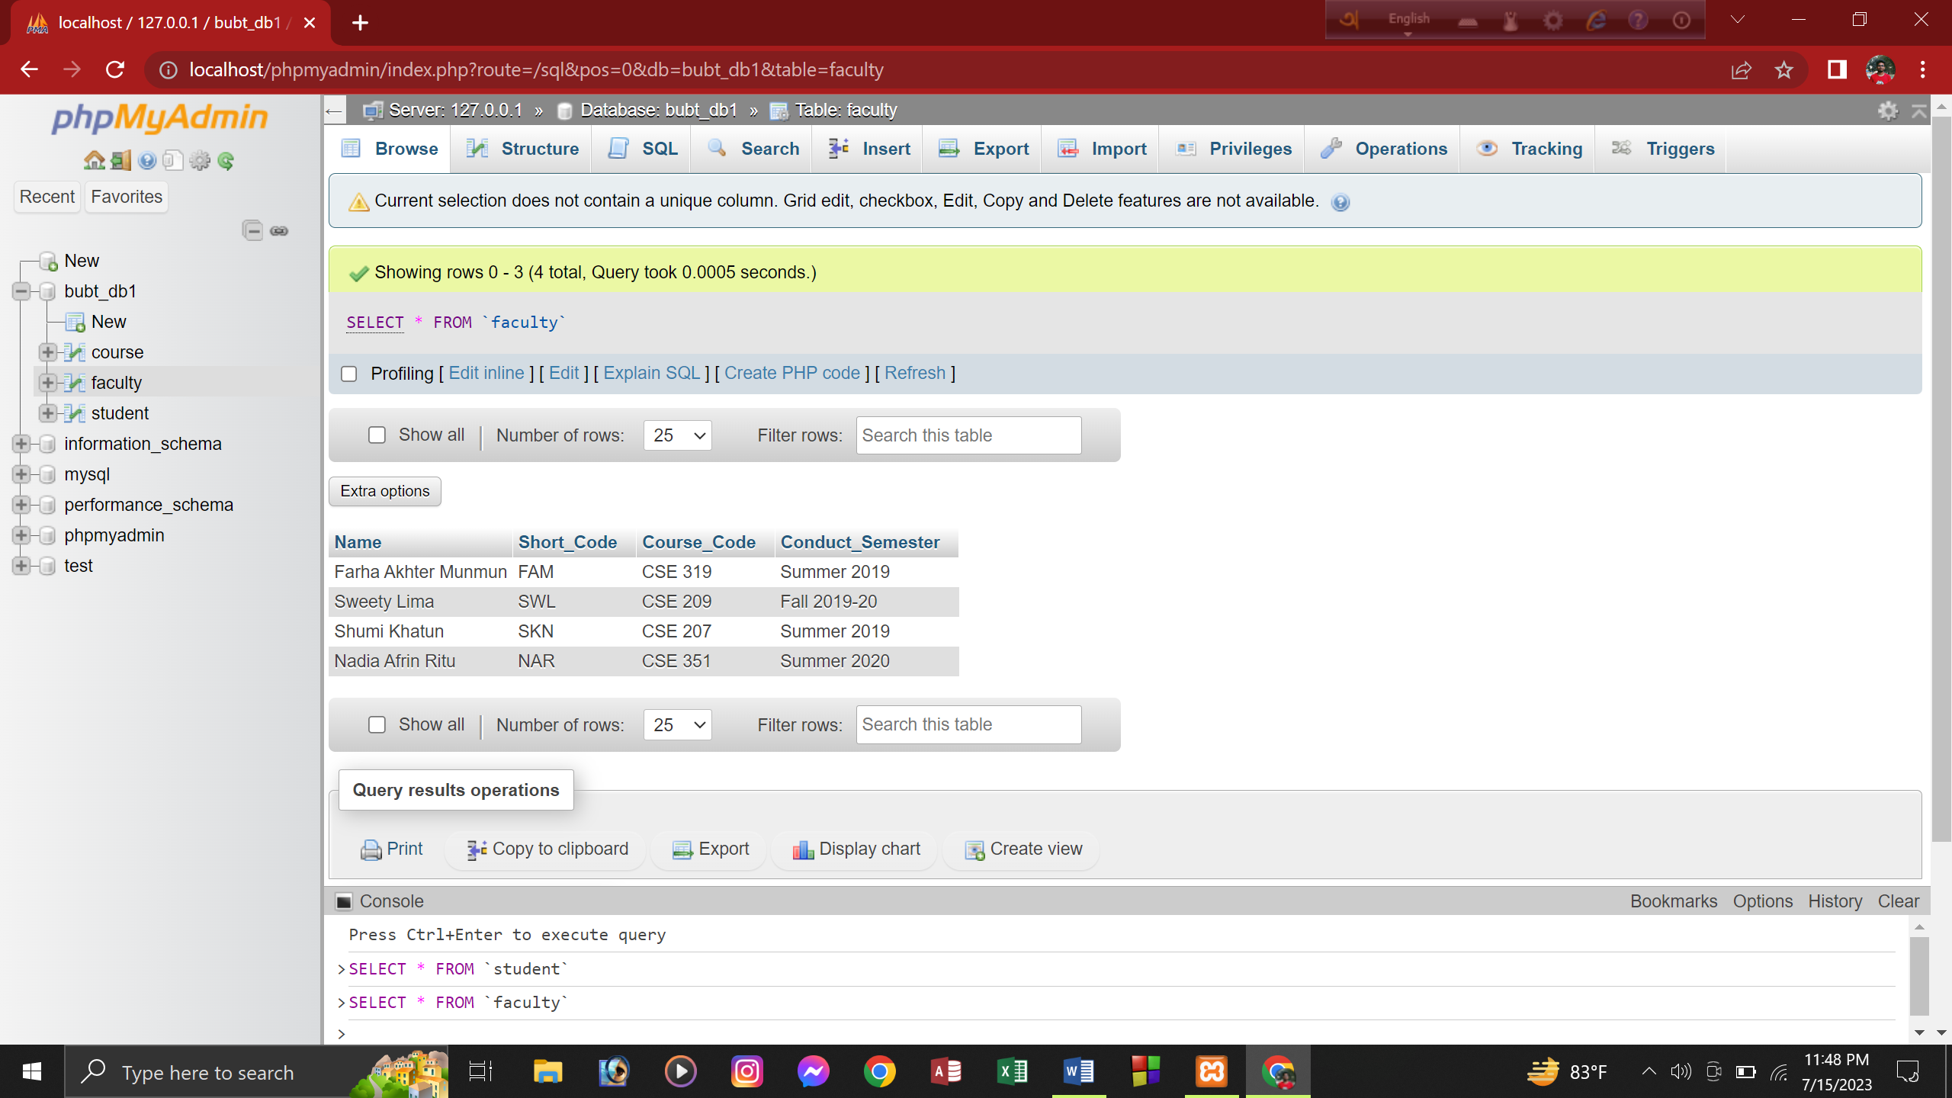

b) Update the course code that is NULL.

Query:

UPDATE faculty SET Course_Code='CSE 207' WHERE Name='Shumi Khatun';



UPDATE course SET Course_Code='CSE 323' WHERE Course_Title='System Analysis Design';

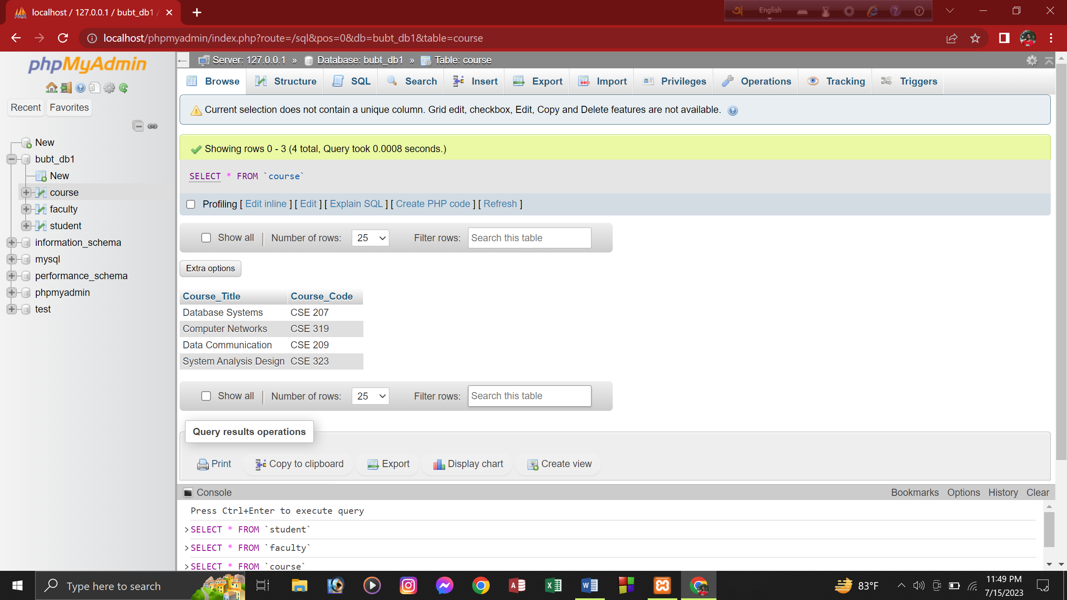

c)Update the conduct semester that is NULL.

Query:

UPDATE faculty SET Conduct_Semester='Summer 2020' WHERE Name='Nadia Afrin Ritu';

d) Add a new column named “Age” in student relation.

Query:

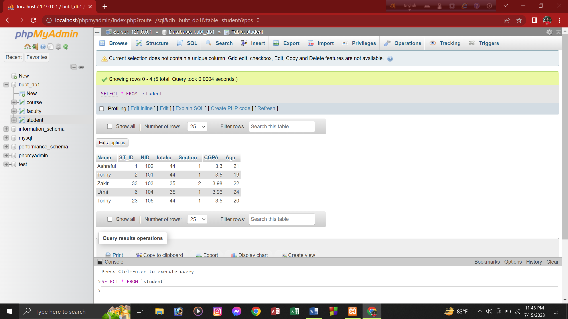

ALTER TABLE student ADD COLUMN Age int(3);

e) Update the age of each student.

Query:

UPDATE student SET Age='21' WHERE NID='102';

UPDATE student SET Age='19' WHERE NID='101';

UPDATE student SET Age='22' WHERE NID='103';

UPDATE student SET Age='24' WHERE NID='104';

UPDATE student SET Age='20' WHERE NID='105';

F) Find the names of all Courses in the Course relation.

Query:

select Course_Title from course;

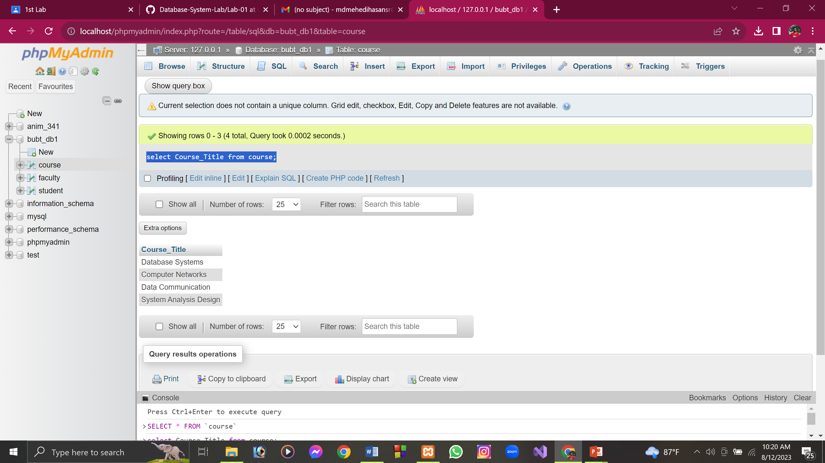

G) Find the names of all teachers who has conducted in summer 2019.

Query:

select Name from faculty where Conduct_semester="Summer 2019";

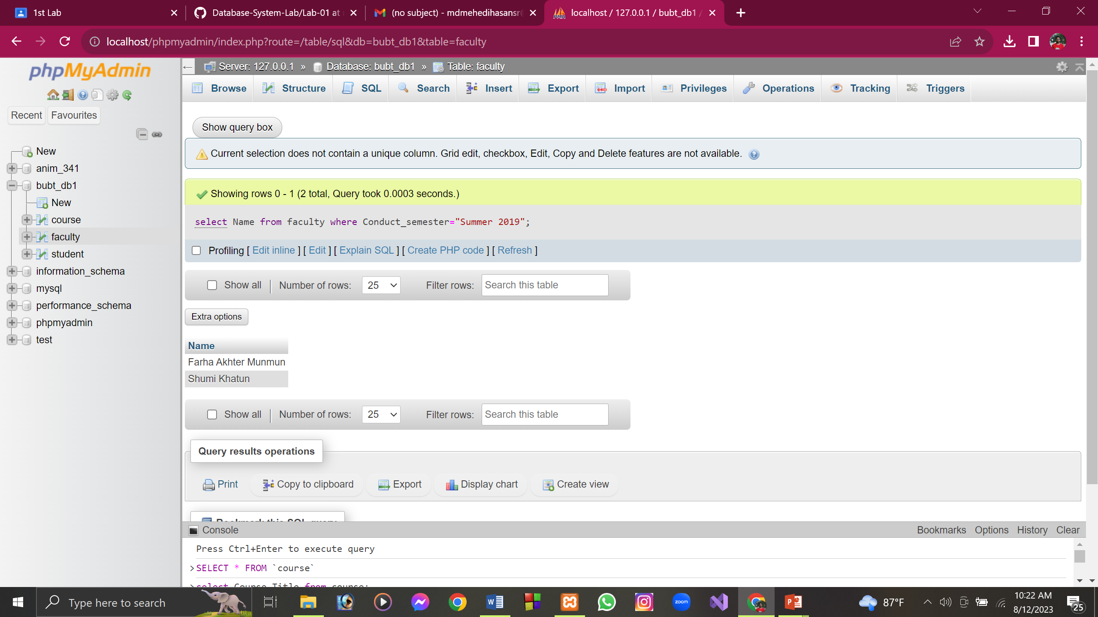

H) Find the names of all students whose CGPA is greater than 3.50

Query:

SELECT Name from student where CGPA>3.50;

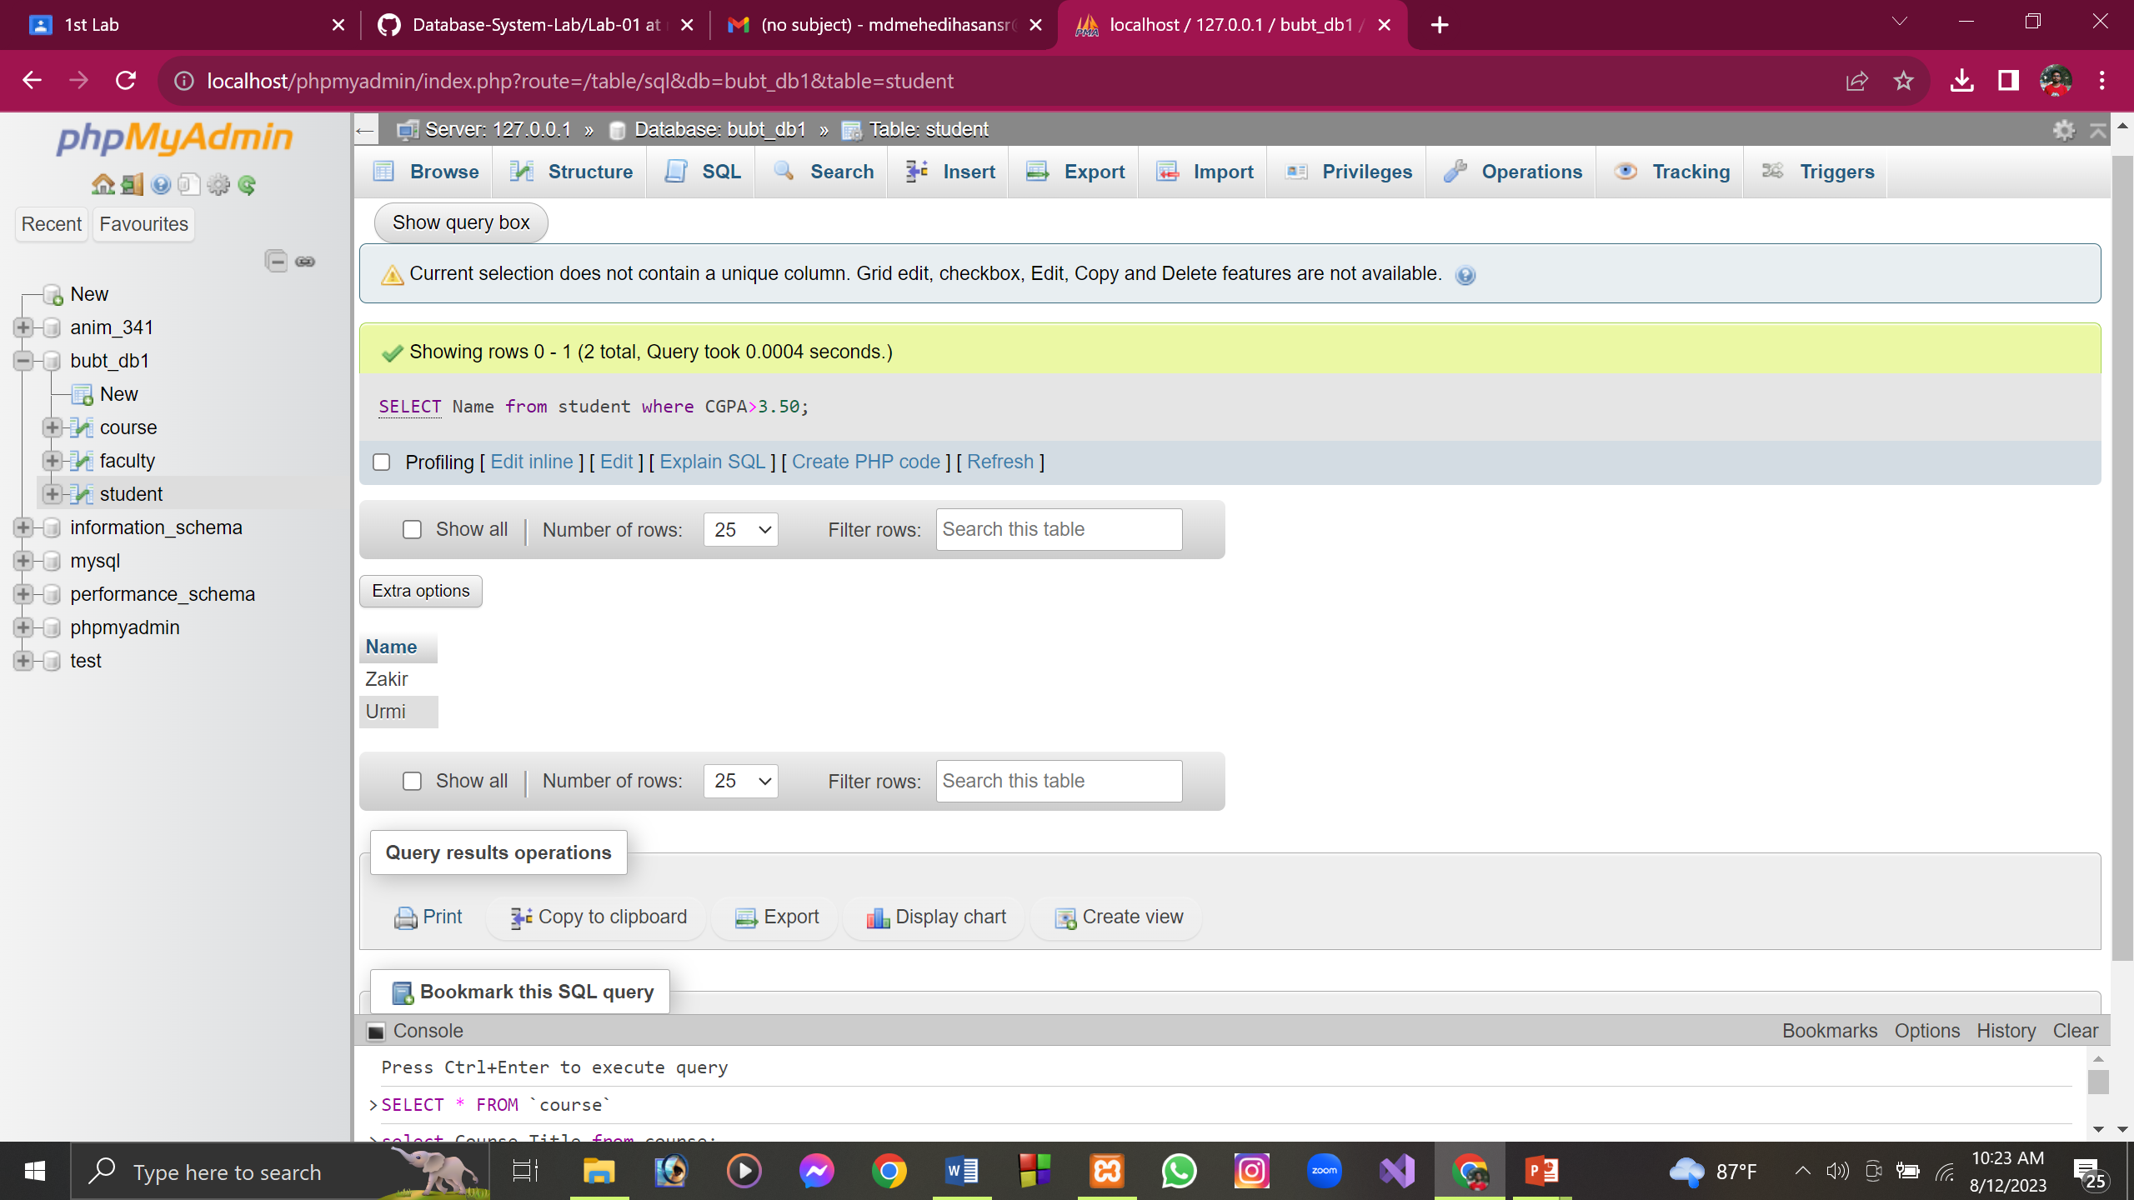

I) Add a new column “Offered Semester” after the column “Course Title”.

Query:

ALTER table course ADD column Offered_Semester varchar(30) AFTER Course_Title;

I) Add a new column “Offered Semester” after the column “Course Title”.

Query:

ALTER table course ADD column Offered_Semester varchar(30) AFTER Course_Title;

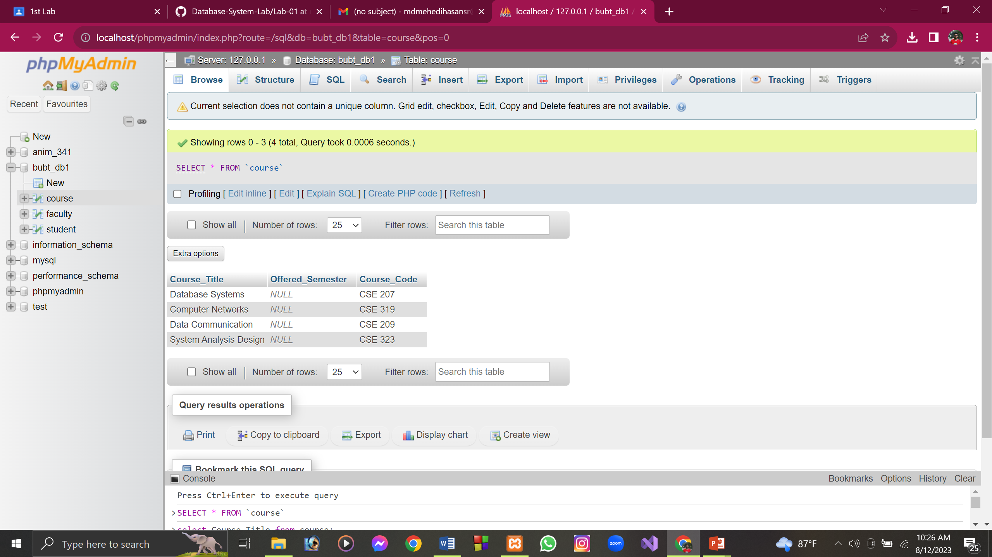

J) Find the name and CGPA of each student order by their CGPA (ascending order).

Query:

SELECT Name, CGPA from student ORDER by CGPA ASC;

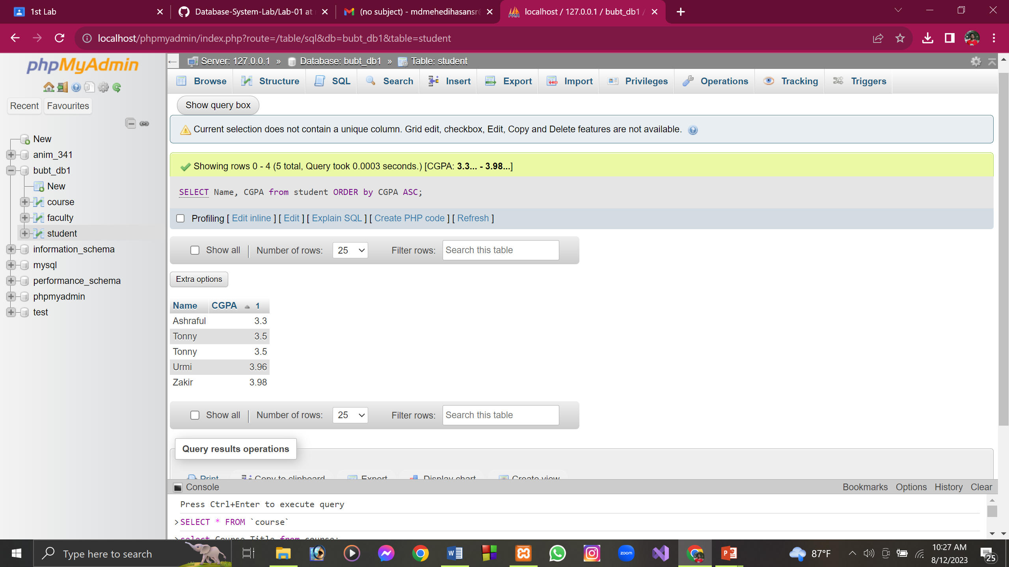

K) Find the name of all students whose age is greater than 22 and CGPA is greater

than 3.50

Query:

SELECT Name from student where Age>22 AND CGPA>3.50;

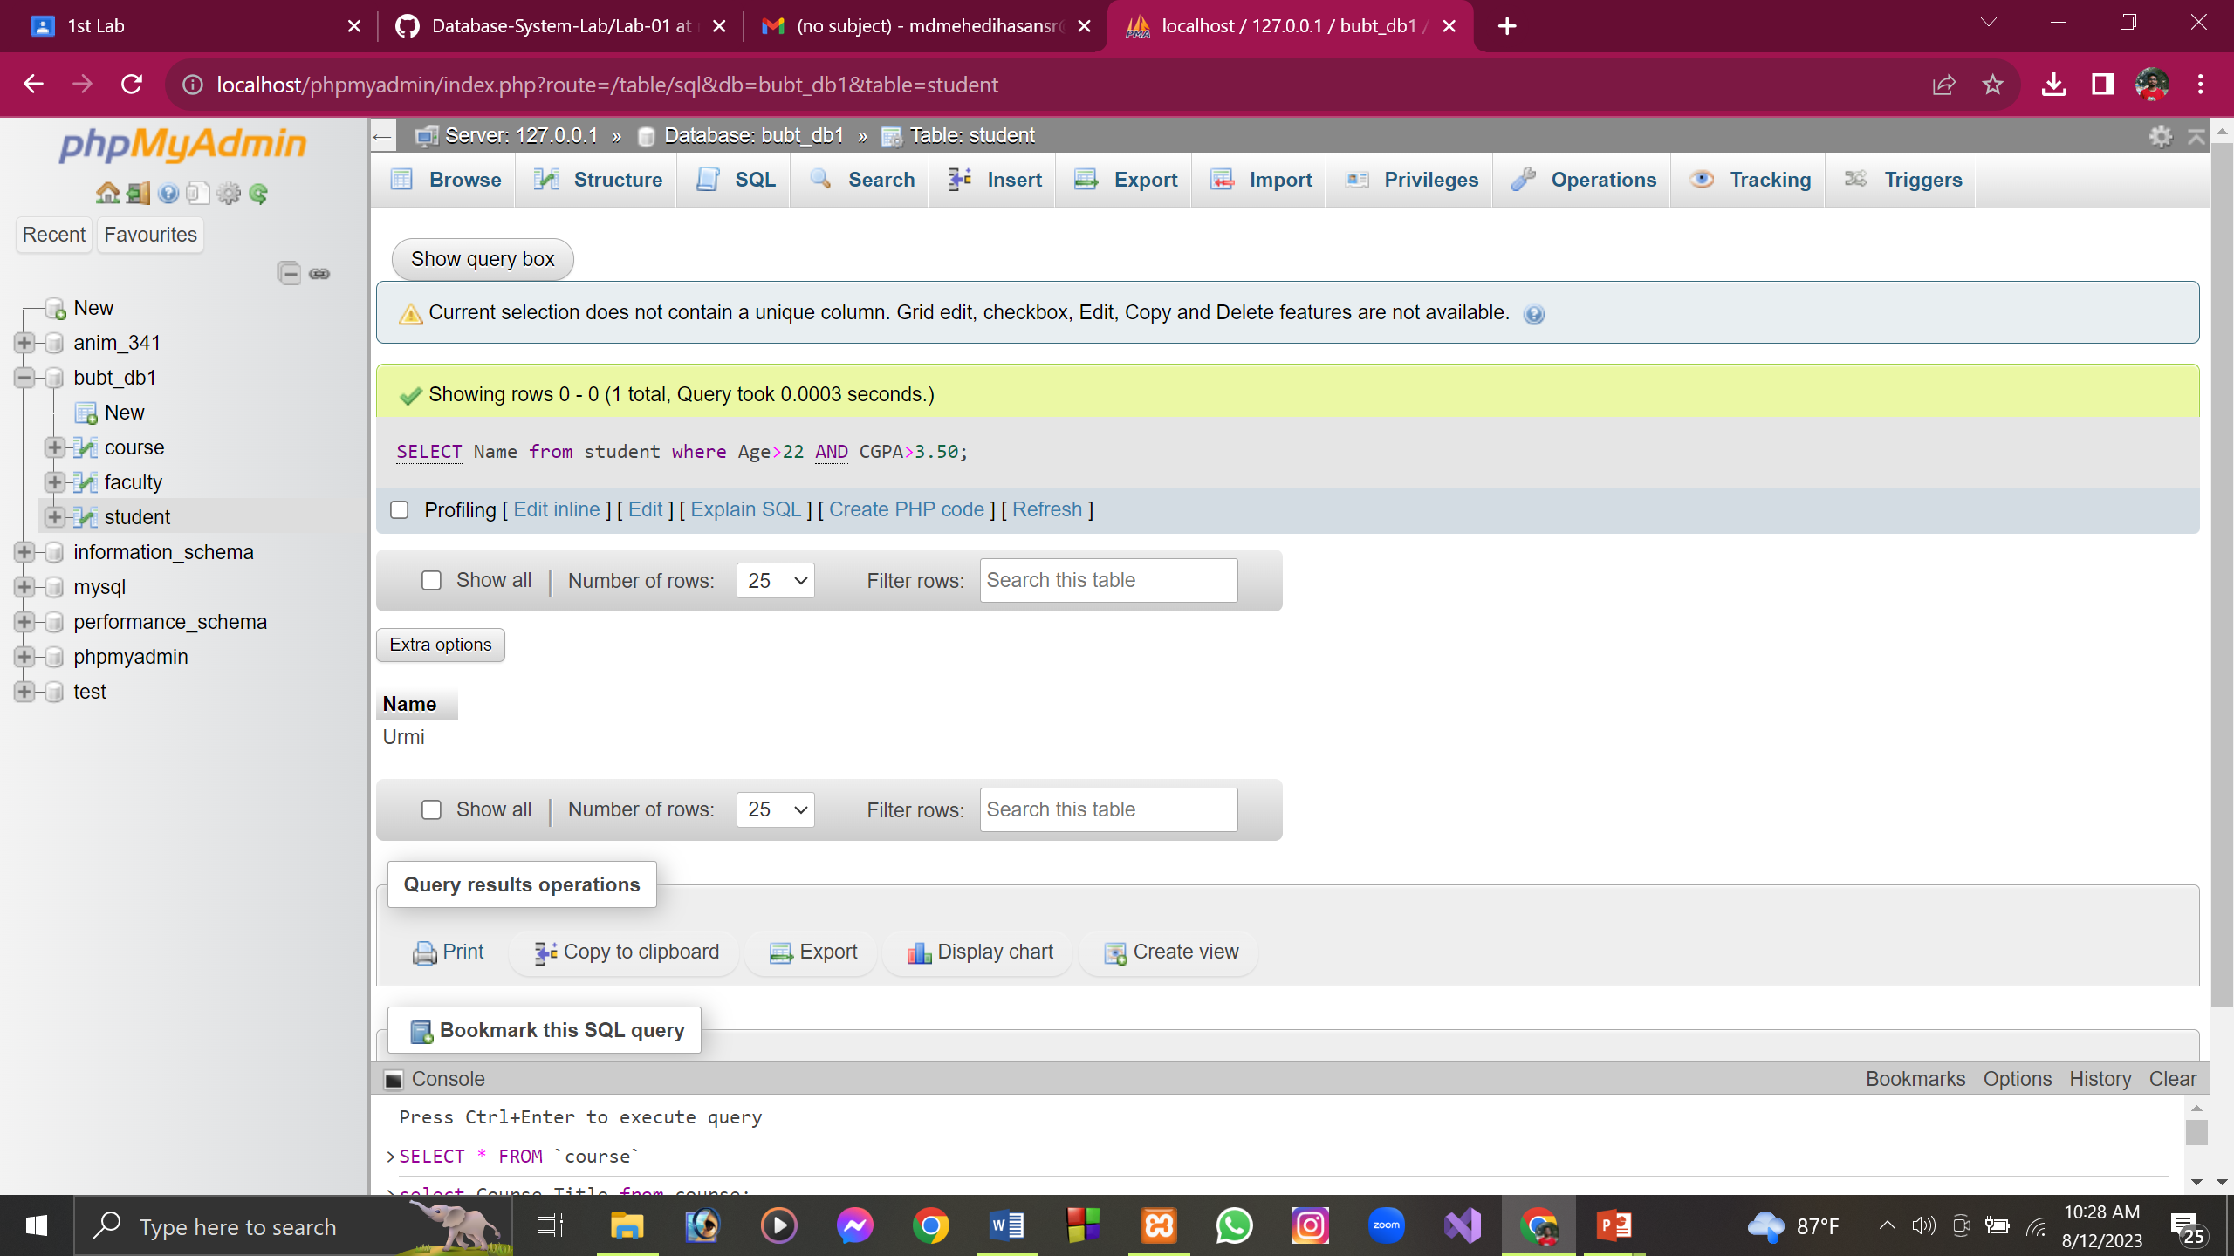

L) Find the ID of all those students who are from 44 intake or CGPA is less than 3.40

Query:

[select](http://localhost/phpmyadmin/url.php?url=https://dev.mysql.com/doc/refman/8.0/en/select.html) ST_ID from student WHERE Intake=44 [OR](http://localhost/phpmyadmin/url.php?url=https://dev.mysql.com/doc/refman/8.0/en/logical-operators.html%23operator_or) CGPA<3.40;

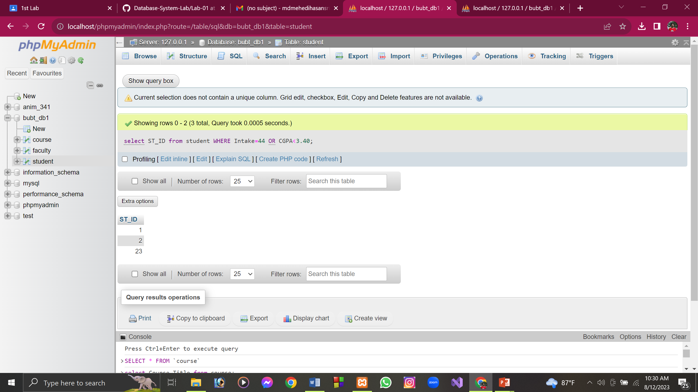

M) Find the ID of all those students whose CGPA is 3.30 or 3.50 or 3.96

Query:

select Student_ID from student where CGPA=3.30 OR CGPA=3.50 OR CGPA=3.96;

[select](http://localhost/phpmyadmin/url.php?url=https://dev.mysql.com/doc/refman/8.0/en/select.html) ST_ID from student WHERE CGPA=3.30 [OR](http://localhost/phpmyadmin/url.php?url=https://dev.mysql.com/doc/refman/8.0/en/logical-operators.html%23operator_or) CGPA=3.50 [OR](http://localhost/phpmyadmin/url.php?url=https://dev.mysql.com/doc/refman/8.0/en/logical-operators.html%23operator_or) CGPA=3.96;

